**AWS 3 Tier Architecture**: -

Create a VPC,subnets,route tables and internet gateway

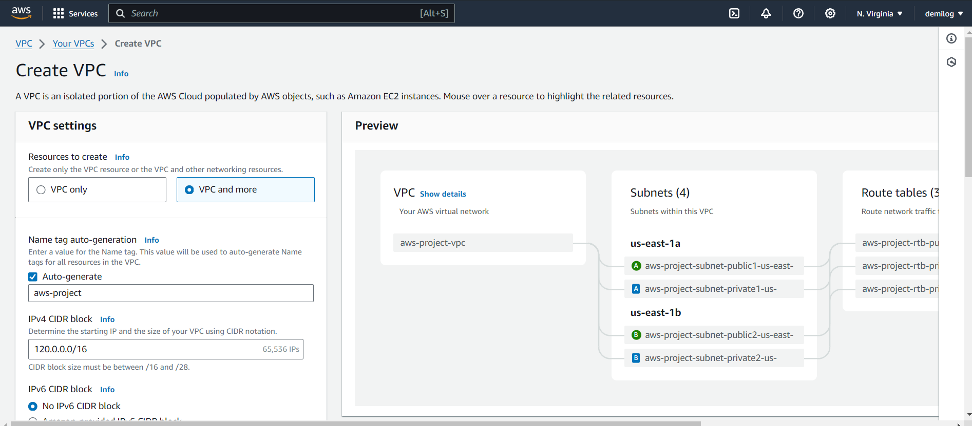

Create 2 public subnets and 4 private subnets

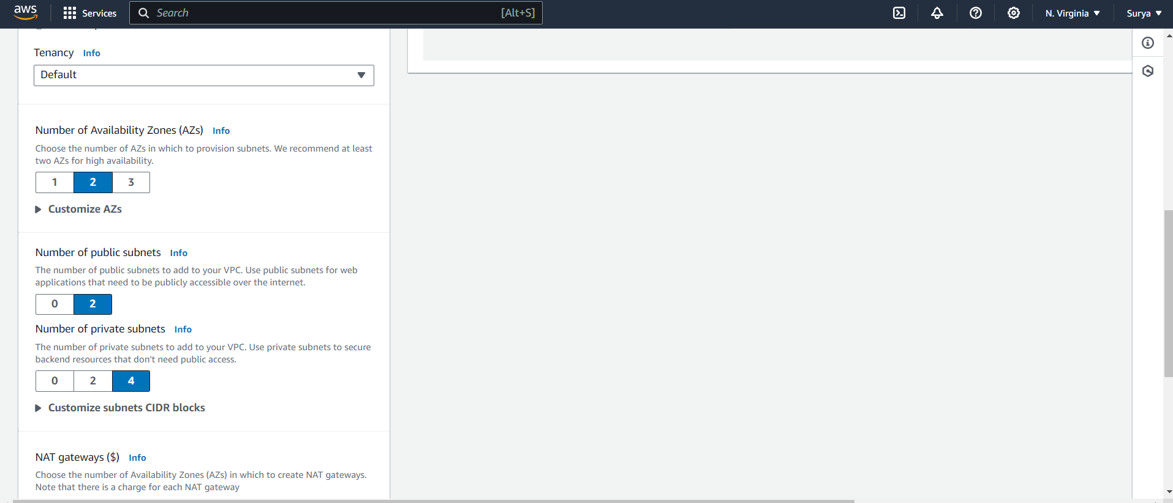final flow chart of VPC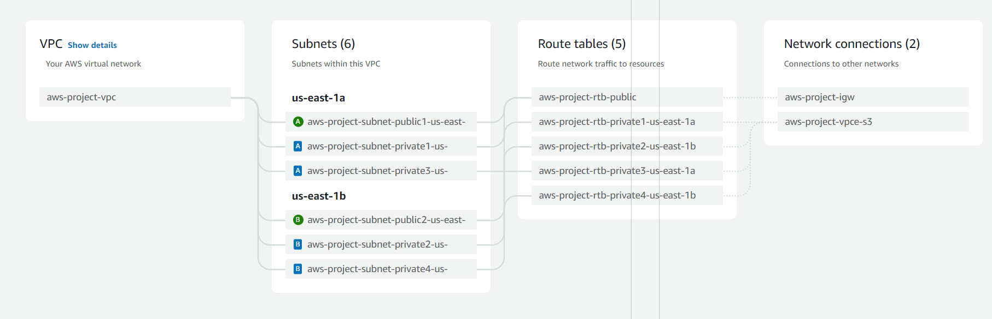

Create a NAT gateways for 2 private subnets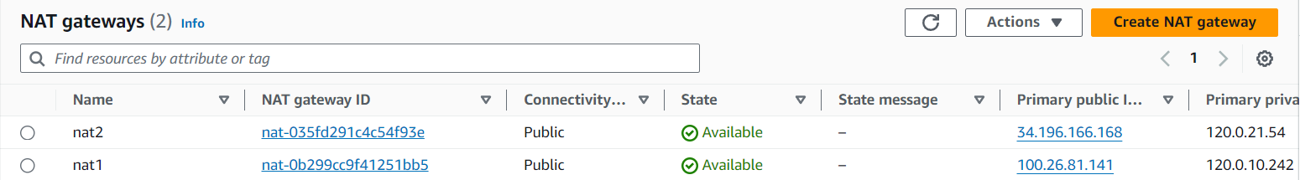

**Creating Database**: -

Add the remaining 2 private subnets into RDS subnet group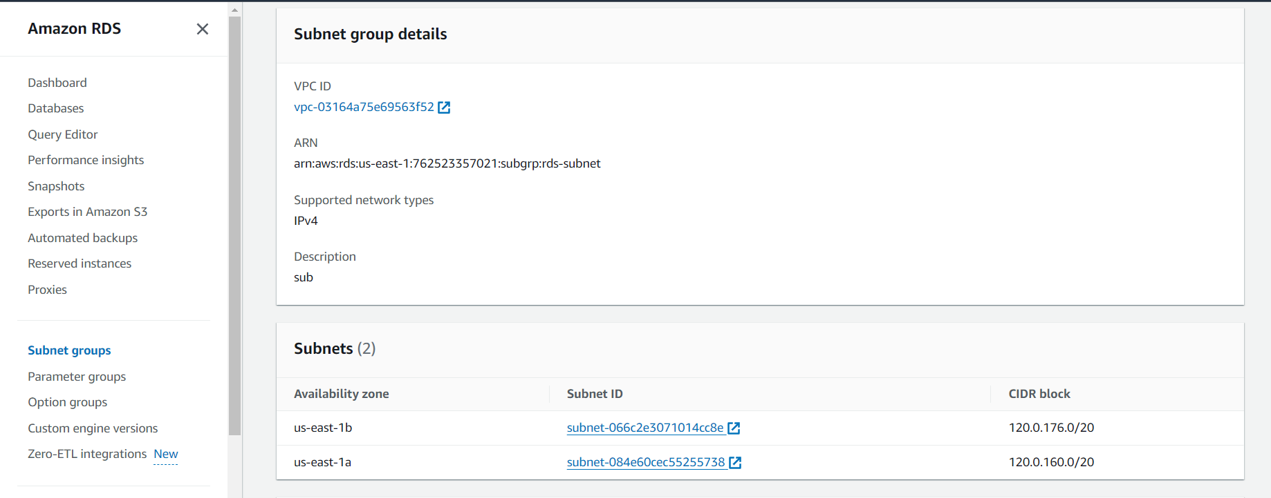create a MYSQL database Cluster 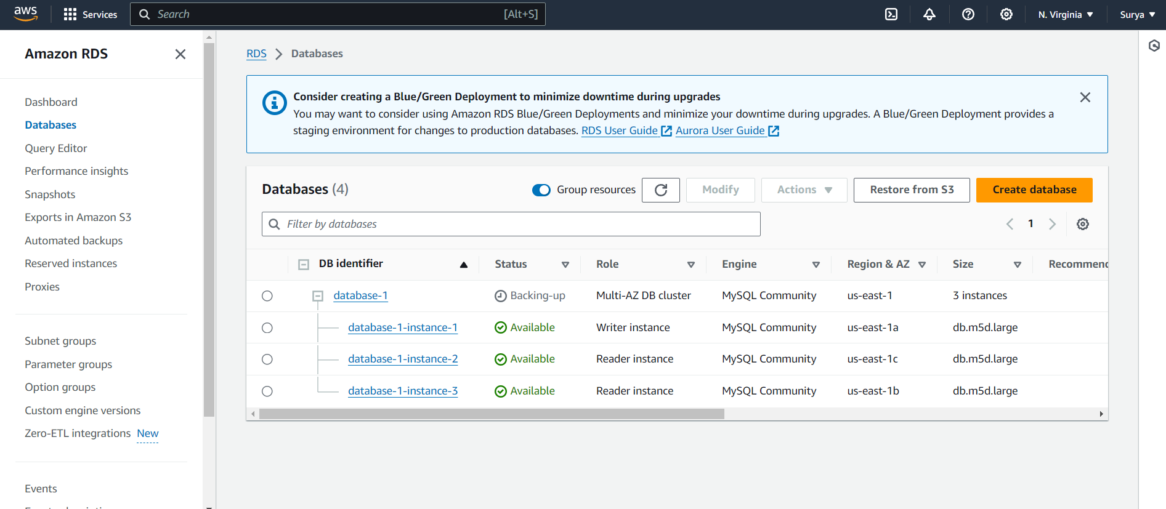**Creating Instances: -**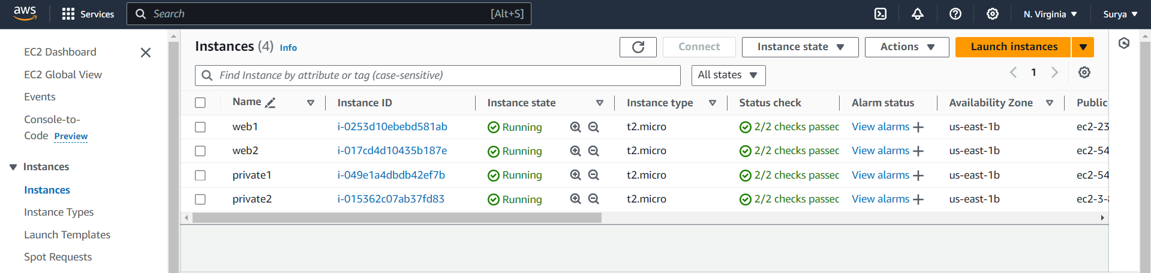

Attaching database to an instance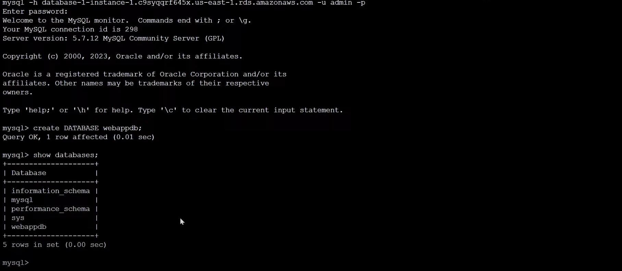**Creating Load Blancers and Auto Scaling: -**

Create a target group

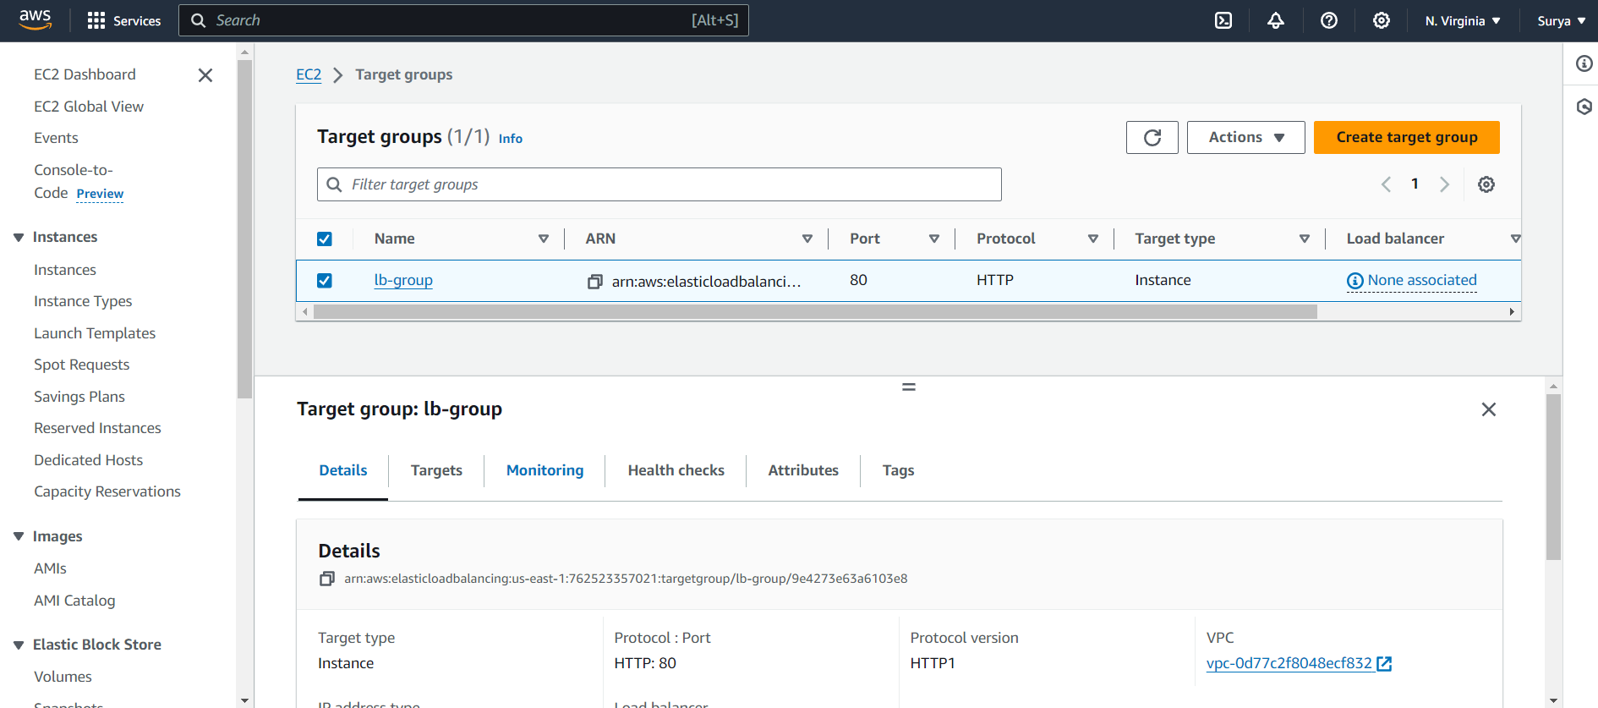create a load balancer using the target group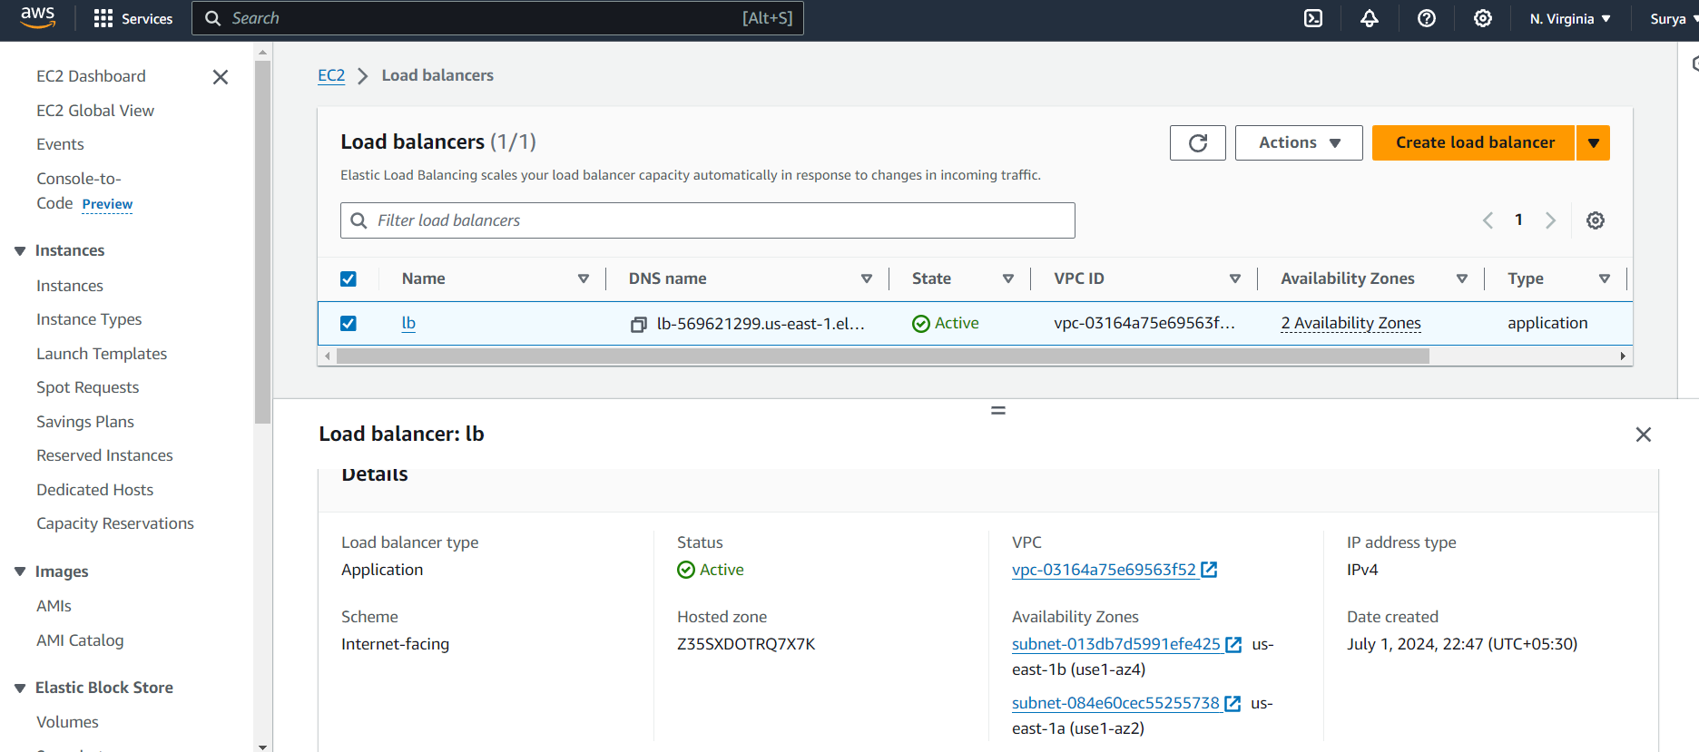

Create AMI from the existing instances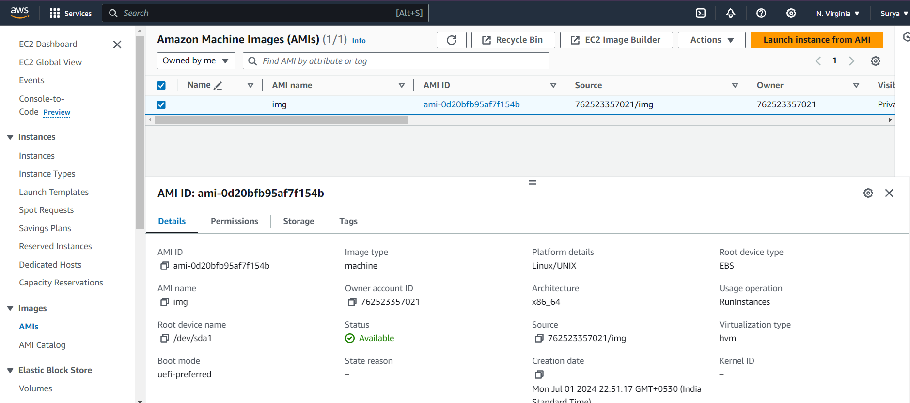create launch template using AMI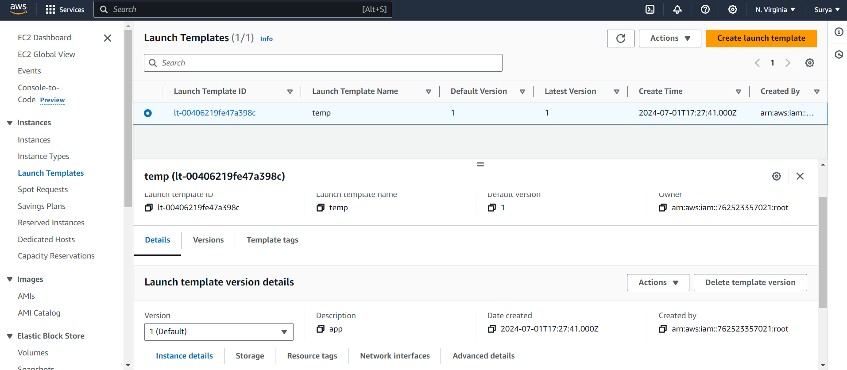create auto scaling group using launch template and load balancer